IMPLEMENTATION OF LIST LINEAR AND BINARY SEARCH USING AN ABSTRACT DATA TYPE (ADT)
Data Structure and Algorithm
Searching Techniques using Arrays in C
Ex. No: 1 | Date: 17.07.2026
Roll no: 25BAD067 | Name: V.Nidhish

Aim:
To write a C program to search for a given element in an array using (i) Linear Search and (ii) Binary Search techniques, and to display the position of the element if found.

Sample Input 1:
Enter number of elements: 5
Enter 5 sorted elements:
10 20 30 40 50
Enter element to search (Linear Search): 30
Enter element to search (Binary Search): 40

Sample Input 2:
Enter number of elements: 5
Enter 5 sorted elements:
10 20 30 40 50
Enter element to search (Linear Search): 25
Enter element to search (Binary Search): 60

Pseudocode for List ADT using Array, Linear Search, and Binary Search:

Algorithm 1: Create and Display List (Array ADT)
START

Read n

For i = 0 to n-1
Read arr[i]
End For

Print all elements of the array
STOP

Algorithm 2: Linear Search
START

Read key

For i = 0 to n-1
If arr[i] == key
Print "Element found at position", i+1
STOP
End If
End For

Print "Element not found"

STOP

Algorithm 3: Binary Search

START

Read key

low = 0
high = n - 1

While low <= high
mid = (low + high) / 2

If arr[mid] == key
Print "Element found at position", mid+1
STOP
Else If key < arr[mid]
high = mid - 1
Else
low = mid + 1
End If
End While

Print "Element not found"

STOP

CODE:
#include <stdio.h>

#define MAX 100

int main()
{
int arr[MAX], n, i;
int key;
int low, high, mid;
int found = 0;

// Create List
printf("Enter number of elements: ");
scanf("%d", &n);

printf("Enter %d sorted elements:\n", n);
for(i = 0; i < n; i++)
{
scanf("%d", &arr[i]);
}

// Display List
printf("List Elements: ");
for(i = 0; i < n; i++)
{
printf("%d ", arr[i]);
}

// Linear Search
printf("\nEnter element to search (Linear Search): ");
scanf("%d", &key);

found = 0;
for(i = 0; i < n; i++)
{
if(arr[i] == key)
{
printf("Element found at position %d\n", i );
found = 1;
break;
}
}

if(found == 0)
printf("Element not found\n");

// Binary Search
printf("\nEnter element to search (Binary Search): ");
scanf("%d", &key);

low = 0;
high = n - 1;
found = 0;

while(low <= high)
{
mid = (low + high) / 2;

if(arr[mid] == key)
{
printf("Element found at position %d\n", mid );
found = 1;
break;
}
else if(key < arr[mid])
{
high = mid - 1;
}
else
{
low = mid + 1;
}
}

if(found == 0)
printf("Element not found\n");

return 0;
}

OUTPUT:
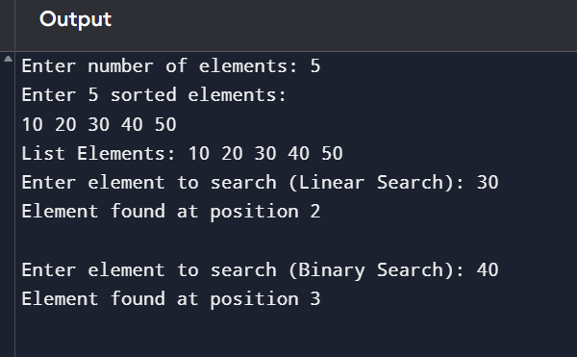

Link:

https://github.com/24CSI024-25ABD067/24CSI024-25BAD067/blob/main/Lab-0%2CQ-1.c

RESULT:
The C program to search an element in an array using Linear Search and Binary Search techniques was written, executed, and verified successfully for both the cases of the element being present and absent in the array.

